2025 AWS in Detroit Wine Tastings
February 23, 2025
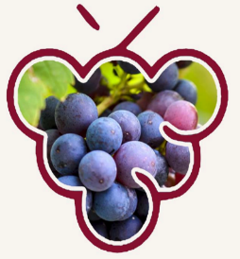
Who Put the “Beau” in Beau-bo-bo-jolais?
(Answer: Gamay Noir!)

Elaine and Chris’ Home

This month it’s all about Gamay Noir grapes. We’ve got wine from various parts of the Beaujolais region, and a ringer just for fun!
Let us know if you would like to be our guest for dinner.

The Wines: Apéritif: Domaine Franck Besson Rosé Granit Brut (Juliénas)
Louis Jadot Beaujolais-Villages 2022
Clos de Mez La Dot Fleurie 2020
Château Thivin Côte de Brouilly 2022
Maison L’Envoyé Morgon Côte du Py 2020
Bulliat Moulin-à-Vent 2015
and one more!

What happened?
A small group tasted the wines at the Fischer/Pearson home. It was perfect for lots of lively conversation. Once all the wines had been tasted, we had a dinner of Lamb and Polenta Lasagna, Caesar Salad and chocolate cake. The clear winners among the wines (using the Brian Geraghty measure of which bottles were empty first) were the Fleurie and the Moulin-à-Vent. The Moulin-à-Vent especially was good with the Lamb.

Make sure to view the detailed tasting notes that Elaine put together for this event. Amazing as usual.

March 16, 2025
SELECT PINOT NOIR FROM THE US AND THE WORLD
Rick & Julie Ganfield
Pinot noir wines are among the most popular in the world. Joel L. Fleishman of Vanity Fair describes them as "the most romantic of wines, with so voluptuous a perfume, so sweet an edge, and so powerful a punch that, like falling in love, they make the blood run hot and the soul wax embarrassingly poetic".Master Sommelier Madeline Triffon calls them "sex in a glass". Pinot noir's home is France's Burgundy region, particularly Côte-d'Or. So we will begin there and discover how the other styles have evolved and compare.
The Wines:
Aperitif –Lucien Albrecht Cremant D’Alsace Brut Rose –France
Joseph Drouhin Gevery- Chambertin Pinot Noir -France
Testify Pinot Noir – New Zealand
Friedrich Becker Family Pinot Noir –Pfalz Germany
Roserock Drouhin Pinot Noir – Eola-Amity Hills Oregon
Denison Cellars Pinot Noir – Willamette Valley Oregon
Belle Glos Las Alturas Pinot Noir - Santa Lucia Highlands Monterey California

A fine selection of cheeses and breads will accompany the wines. Please bring your own glasses and pens. No smoking or strong fragrances.
What happened:
The tasting was well received. It was unusual in that Rick started with the most expensive wine, the Gevrey Chambertin gran cru and then branched out to examine the differences in other regions based on their terroir. The tasting was followed with a raise of hands as to who would enjoy these wines again.
Each of the following wines received the same number of votes:
Joseph Drouhin Gevery- Chambertin Pinot Noir -France
Roserock Drouhin Pinot Noir – Eola-Amity Hills Oregon
Belle Glos Las Alturas Pinot Noir - Santa Lucia Highlands Monterey California

April 13, 2024 Reach for a RIOJA
Geraghty/Charron
A wine article in a December issue of the Wall Street journal indicated that many Riojas in the $20 - $40 range drink like $60 - $120 California cabernets. Why not drink what you love instead of drinking a label. Come and taste these wines to see if you agree.
Wines to be tasted are:
Aperitif:
2018 Gelida Brut Gran Reserva Cava Barcelona
The wines:
2020 Lucia Victoria Tempranilla Rioja
2020 Leza Garcia Jinto Familia Crianza Rioja
2020 Senorio de Odon Crianza Rioja
Kalimotxo Cocktail
2019 Burga Viejo Licenciado Rioja Reserva
2015 Reciente Bodegas Olarra Rioja Gran Reserva
2017 Cune Rioja Gran Reserva
What happened?
All of the wines were thoroughly enjoyed. Of the first set of three, each one was progressively enjoyed more and the attendees appreciated the bargain prices of these delicious wines.
Those who like Coca-cola emjoyed the cocktail which was a 50/50 mix of rioja and Coca-cola with an added slice of orange. This cocktail is often featured at outdoors festivals in the Basque region of Spain where it is mixed in large bowls.
Following the Kalimotxo Cocktail were the more serious wines, the reservas and gran reservas.

May 18, 2025
Exploring Wines on the Iberian Peninsula
The Mikulak’s
Apéritif: Jaume Serra Bouquet Cava Brut
Cocktail : Vermut Lustau with Orange Juice or Sparkling Water
The Wines:
2019 Pagos de Galir Mencia (Valdeorras denominación de Orixe)
2021 Esteban Martin “Joven Red Blend (Garnacha / Syrah)
2021 Casa Ferreirinha Papa Figos Douro DOC (Tinta Roriz / Tinta Barroca / Touriga Franca / Touriga Nacional)
2021 BlueGray Red Blend (Garnacha / Carinena / Syrah / Merlot) (Prioat Denominacio de Origen Qualificada)
2020 Los Tres Pacos Mas Buscados Red Blend (Tempranillo / Syrah / Petit Verdot (Vino de la Tierra de Castilla)
2020 Tres Picos Garnacha (Denominacion de Origen Campo de Borja)
What happened:
13 Detroit area AWS members and guests joined hosts Rick & Miriam Mikulak for a trip back to Spain and Portugal to learn about other varietals and sample wines made from this great wine-producing region.
As the members arrived, we served a sparkling Jaume Xerra Bouquet Brut Cava, from a vineyard 30 minutes from Barcelona and reputed to be "the vineyard closest to the sea" in Spain.
Grape varieties used for this Cava: Macabeo, Xarel-lo and Parellada
The next wine was another aperiti, Lustau Vermut Rojo (Red Vermouth) made from a baxse of Amontillado and Pedro Ximenex sherries, and a blend of botanicals (wormwood, gentian, coriander and orange peels).
This is an excellent digestif, and can be blended into cocktails with citrus juices or soda water.
We then tasted six red wines:
2019 Pagos de Galir Entoma Mencia.
This wine is made from primarily Mencia grapes with a mix of other varieties, such as brancellao, souson, garnacha tintorera and alicante bouschet.
The winery is in the village of Entoma, in the Galir Valley in Ourense, Galicia (NW Spain).
2021 Esteban Martin Joven (Young)
This wine is blended from Garnacha and Syrah grapes in a 60% to 40% ratio in the Carinena PDO or Protected Designation of Origin.
Our next vineyard is located in the Douro Valley of Portugal:
2021 Casa Ferreirnha Papa Figos Red Blend.
4 grapes were blended for this selection: 30% Tinta Roriz (same as tempranillo); 30% Tinta Barroca; 25% Touriga Franca; and 15% Touriga Nacional.
This wine uses stainless steel tanks and produces a wine with notes of black & red fruit, a balsamic aroma, and cocoa and chocolate hints.
This wine also comes from a DOC (Controlled Region Denomination) Douro.
For our next wine we are tasting a 2021 Blue Gray Red Blend.
The varietals are 40% Garnacha; 30% Carinena; 20% Syrah and 10% Merlot.
this is from the Priorat DOQ (Qualified Origin Denomination), a mall steep appellation in Catalonia, 90 miles south of Barcelona. Soil composition is unique: llicorella, a quartz-rich blue slate, with low yields of small, cncentrated berries.
Wine # 5 was from the Jumilla DOP (Protected Origin Denomination) in the Province of Murcia, in the southeast of Spain.
This 2021 Juan Gil Jumilla was made from 100% Monastrell (mourvedre) grapes, selected fro old vineyards with low yields planted on limestone and very stony soils. This results in a wine with a deep red color, abundant fruit aromas and a long spice, well-balanced finish, and toasted notes from the French wood.
We completed our tour by sampling a 2020 Borsao Tres Picos from the Campo de Borja DO (Origin denomination) in the northern province of Zaragoza.
The grapes were harvested from old vine Garnacha vineyards that cling to rugged terrain on the slopes of the Moncayo mountain. Low yield produce a deeply colored and aromatic wiine with concentrated flavors of blackberries, strawberries and nuances of leather, vanilla and plums.
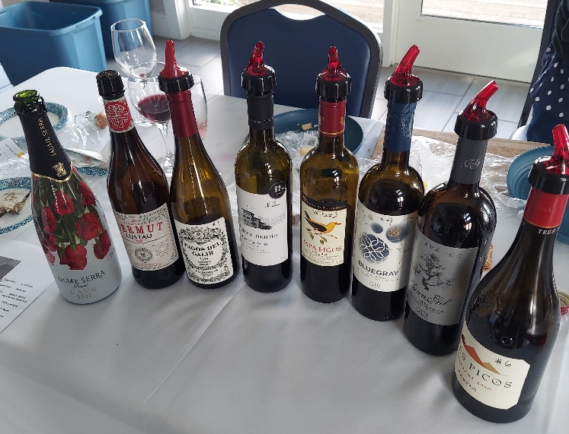 | 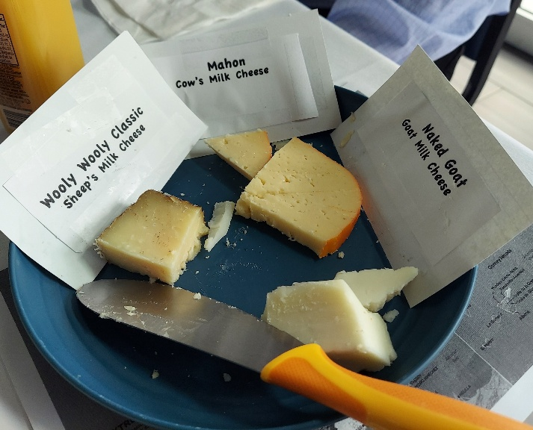
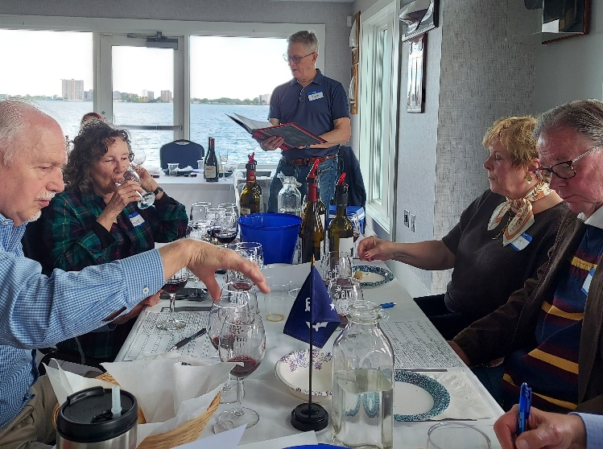 | 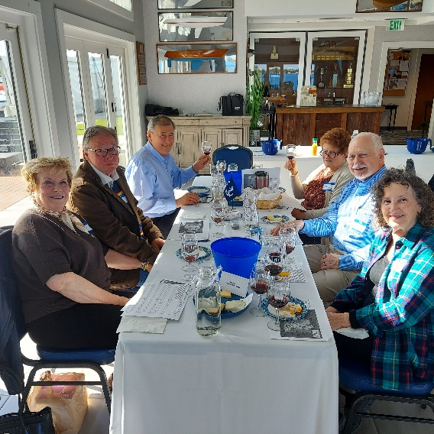
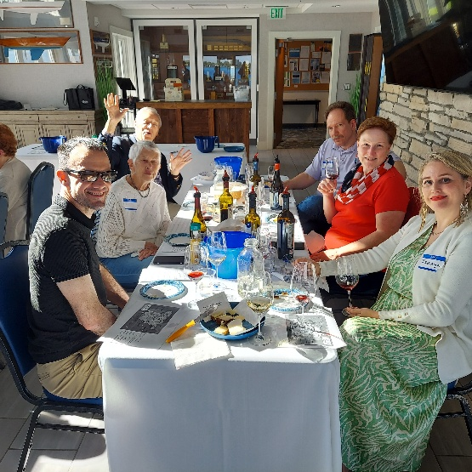 | 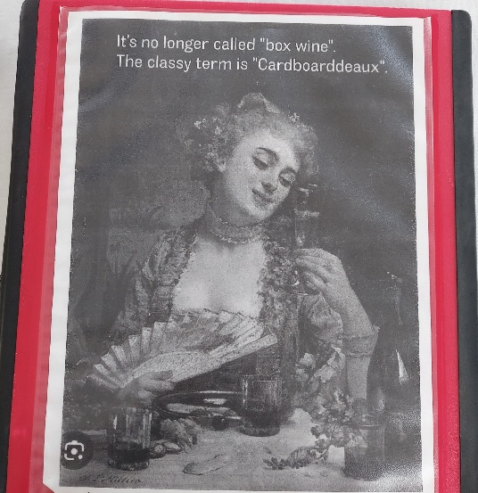

June 22, 2025
Wines of Portugal
Bernd Mueller and the Reed’s
It’s time to explore the delicious wines from the Vinhos Verdes, Dao, Lisboa, Alentejo, and Douro Wine Districts.

The Wines:
Portal De Calcada Cuvee Prestige Sparkling Vinho Verde
2023 Vinho Verde Loureiro - Alvarinho, Portal da Calcada
2023 Dao Branco Colheita Selecionada, Cabriz
2020 Dao Colheita Selectionada, Quinta de Cabriz
2019 Lisboa QSS Rare, Quinta de Sao Sebastiao
2020 Vinha da Contada Velha
2022 Doura Filipe Ferreira, Mary Taylor
What happened:
The attendees thoroughly enjoyed these wines. They are easy to enjoy with a meal on a cold clammy day.
Wine #1 PORTAL DE CALCADA PRESTIGE SPARKLING VINHO VERDE Brut sparkling showing a fine and elegant bubble, floral note and a slight brioche.
Wine #2 2024 VINHO VERDE LOUREIRO – ALVARINHO Blend, PORTAL DACALCADA Stone fruit flavor appeal. Nice acidity; florals, pineapple, pear, maraschino.
Wine #3 2023 DAO BRANCO COLHEITA SELECIONADA, CABRIZ Blend 40% Encruzado, 20% Bical, 20% Malvasia Fina, 20% Granite terroir and combo of fruit and minerality.
Wine #4 2022 DAO COLHEITA SELECIONADA, QUINTA DE CABRIZ Blend 40% Alfrocheiro, 30% Touriga Nacional, 30% Aragonez. Granite core and black fruits, bright and silky, raspberry tart, blood orange peel and wild sage. Well-spiced, persistent finish.
Wine #5 2019 LISBOA QSS RARE, QUINTA DE SAO SEBASTIAO Blend 13.5% alc 60% Touriga Nacional, 30% Cab Sauv, 10% Syrah. Full, aromatic, layers of red fruits, and flavorful fine touch of spice.
Wine #6 2020 VINHA DA CONTDA VELHA Private Biodiversity Reserve, Red Blend 30% Aragonez, 30% Trincadeira, 30% Syrah, and 10% Cabernet Sauvignon. Medium purple, with cherry, blackberry and plum, and peppery spice.
Wine #7 2022 DOURA FILIPE FERREIRA , MARY TAYLOR 13.5% Alc Red blend 60% Touriga Nacional, 15% Touriga France, 25% Tinta Roriz, Bouquet is deep, complex, black fruit in a mix of dark berries, cassis, saddle leather, cigar wrapper, dark soil tones, smoky top note.

August 17, 2025 Member Appreciation
The Nesler’s

September 21, 2025 Almost Totally Zinfandel
The Geraghty’s
Get ready for fall. Come to this wine tasting of red wines that are available now in your local Total Wine & More store. Almost all of these wines were chosen from the Total Wine shopping categories of: “Wines that taste expensive” and “Red Hot Summer savings”, hence the excellent cost point of this tasting.
We will start with a comparison of sun-drenched zinfandels from California. Then we’ll taste zinfandel from Italy along with other pasta and meat friendly Italian wines. The tasting finishes with an age-worthy wine from your local Costco.

Aperitif : 2021 Levert Freres Cremant de Bourgogne Blanc Brut

The wines:
2023 Double Black Zinfandel – Paso Robles
Harvester Zinfandel NV – Paso Robles
2022 Oak Ridge Zinfandel Ancient Wine Estate Grown – Lodi
2022 Pazzia Primitivo Puglia IGP
2020 Marchese di Borgosole Salice Salentino Riserva
2019 St. Giorgio Toscana IGT Super Tuscan
2021 Kirkland Signature Barolo DOCG
What Happened?
Wines were enjoyed by all. This tasting may be duplicated at the Venice, FL chapter, by one of our world travelers when he is down south.

October 19, 2025 Planning Meeting
The Nesler’s
This tasting featured so many different wines provided by both the hosts and the guests. The dinner prepared by Sherry was spectacular. Best ribs ever.
Our Pres did an excellent job in securing hosts for the tastings in 2026.

December 13, 2025 Champagne Tasting
The Carson’s at the Nesler’s
The champagnes:
Aubert Et Fils Brut Champagne
Baron-Fuente Grande Reserve Brut Champagne
Bernard Gaucher Reserve Brut Champagne
Thienot Brut Champagne
Collet Brut Champagne
What happened?
Frank and Jackie led the testing of the champagnes. Frank believes that the Aubert Et Fils Brut may also be the Kirkland branded champagne at half the price. Due to tariffs, fewer champagne choices were available. These 5 champagnes were tasted by club members in the past, possibly over the last ten years.
There was quite a spread of hors doeuvres at the home of Sherry and Roy Nesler. The group voted on their favorites. Rick and Miriam Mikulak won 2nd place with grilled artichokes and champagne sauce. Bernd Mueller won first place with his terrine of chicken. Congratulations. Some of the other hors’ doeuvres included caviar on egg, artichoke dip, blue cheese and walnut squares, quiche with peppers and Canadian bacon, salmon spread, Chinese chicken, and champagne cheese.
Desserts were a lemon cake, French cake, brownies and fruit cake.
Photos courtesy of Jon Reed.
 |  | 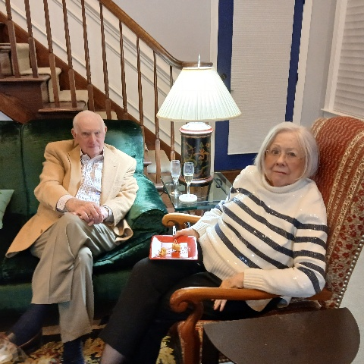
Bernd at his Best | Frank & Jackie | Brian and Pat
 | 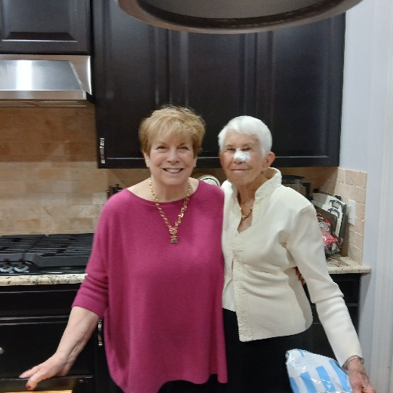 | 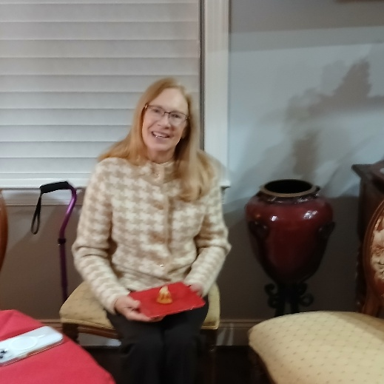
Bernd, Rick & Julie | Sherry and Joan | Susan
 |  | 
Three Musketeers | First Place | Second Place

The Group

